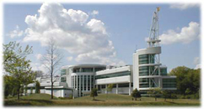
In Recognition of 50 Years of
the Atmospheric Sciences Research Center at U-Albany.
http://asrc.albany.edu/about/history.htm
"As long as we give young minds the privilege and the facilities to roam far and wide, and from time to time play with impractical things as snow crystals, they are bound to come up with some exciting new angles on the mysteries of nature."
Vincent J. Schaefer, Aug 15 1960, proceedings of the dedication symposium Boeing Research labs.

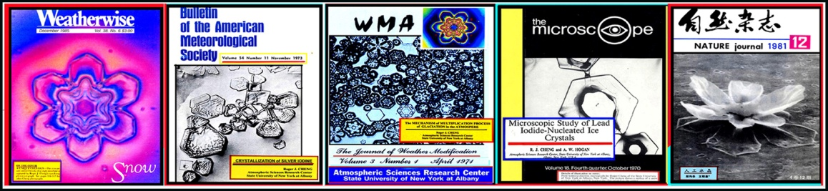

When contemplating the formation of ASRC, Vince Schaefer and colleagues had in mind the research atmosphere that he and colleagues had thrived in at the GE Laboratories. Schaefer often recalled that Willis Whitney, GE lab director, querying the researchers if they were ‘having fun’. Schaefer, encouraged by SUNY officials to start the ASRC, was certain that offering good people a place to thrive would result in good science. Schaefer brought highly qualified atmospheric science researchers to ASRC, many of whom he had met through his work at GE and the Munitalp Foundation. Bernard Vonnegut, Raymond Falconer and, in 1968, Duncan Blanchard, all veterans of the late 1940s-1950s era Project Cirrus joined Schaefer at ASRC. A resulting collateral benefit was that the consequent research resulted in funding that the University welcomed.
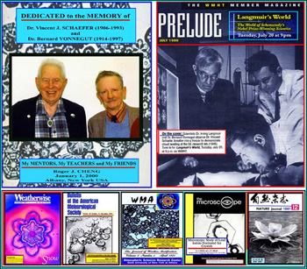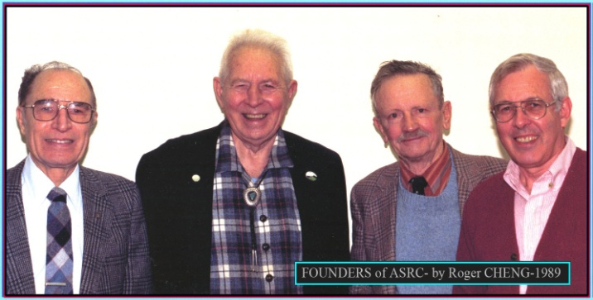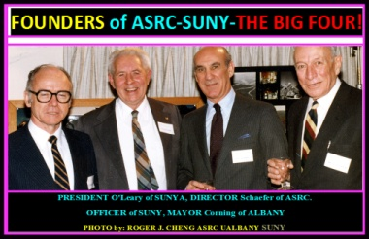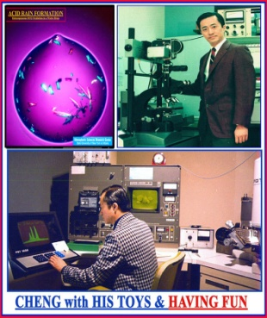

What makes the ASRC different from an academic department? In an academic department, researchers are assessed as to whether they ‘fit in’ and complement teaching and research needs. At ASRC, researchers are encouraged to ‘deal with the freedom’. As time went on the state supported research positions, such as those at ASRC, became exceptional nationally. Schaefer and colleagues championed the unexpected opportunities that arise in research, referring to it as ‘serendipity,’ the idea that ‘chance favors the prepared mind.’ Blanchard recalled that the idea was to seek a climate in which ‘it was fun to do research.’

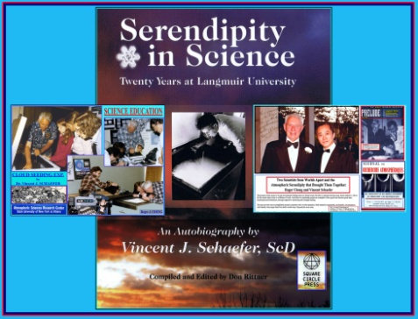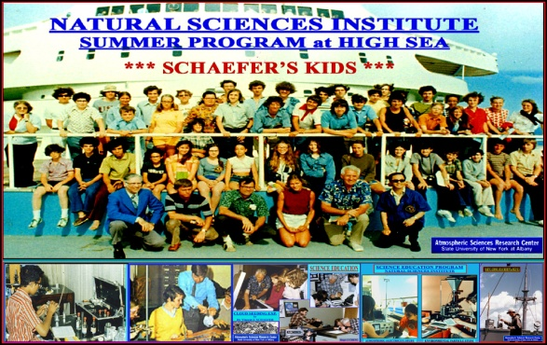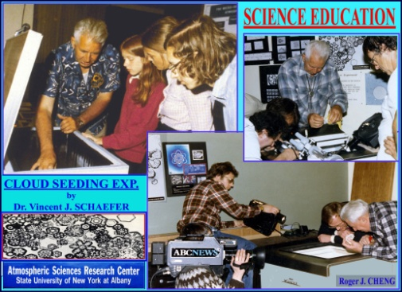

In the very early days, Schaefer ran a series of Natural Science Institutes, summer research-oriented programs, to encourage high school students.

Since 1997, ASRC has been housed at the Center for Environmental Sciences and Technology Management (CESTM) at 251 Fuller Road. Over the years several recurrent themes distinguished research at ASRC.

Microphysics of Aerosols and Cloud Droplets.

In 1966, Roger Cheng arrived as a technical assistant for Schaefer and stayed at ASRC for 32 years. Roger made several striking observations based on the study of single water drops.
With Schaefer, Roger helped explain how electric charges were generated in a thunderstorm cloud.

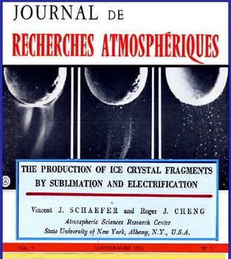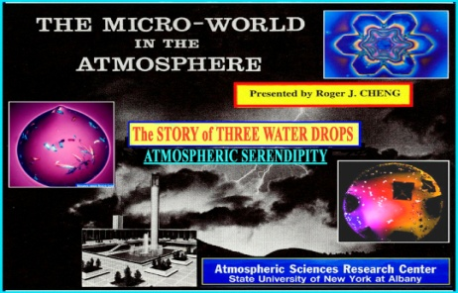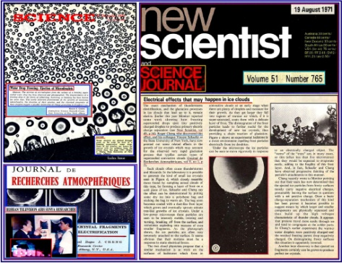

His photomicrographs have become very well known. Among many other findings, Roger and colleagues discovered in 1986 that some sea salt particles were hollow and not solid as formerly believed.
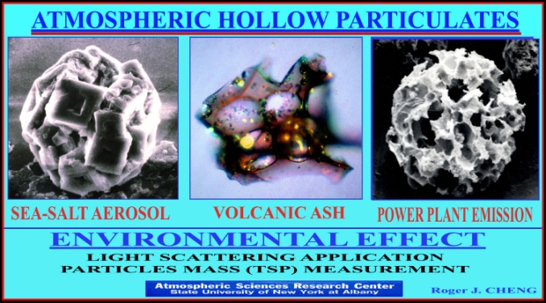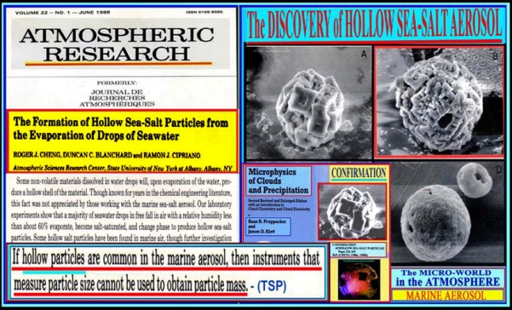

How will ASRC evolve next?

"Will our adventurous quest of innovative thinking be dulled and dented because of the massive job that must be done, the ‘nit-picking’ of pedestrian professors or the cautious delays of frightened politicians or administrators?", V. J. Schaefer, November 1 1967 "University lecture: Things in the air", delivered to students at UAlbany.

We seem to be in an era of ‘fee for service’ science, one in which the requests for proposals sound like demands for products. Despite this, we believe Schaefer’s idealism still has a place. There are some projects that one thinks are worthy of the ASRC founders’ call to ‘curiosity’, projects that the funding agencies might (at least at first) find puzzling.

There are Roger Cheng’s fantastic photomicrographs of freezing droplets and the microphysics of pollution.
